”Guidelines for Dating Early Photographs"

D Sue Kissel dskissel@cableone.net
Supplies

- Hollinger Metal Edge http://www.hollingermetaledge.com/

- Gaylord Archival https://www.gaylord.com/

- University Products https://www.universityproducts.com/

- Also check Wal-Mart, Office Max and Staples

Online Resource Freebies
https://www.gaylord.com/c/Book-and-Pamphlet-Preservation
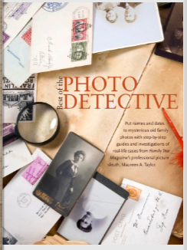
http://online.anyflip.com/amso/annl/mobile/index.html

http://www.loc.gov/rr/print/resource/Reading_Researching_Photographs.pdf

Helpful Websites for Dating photo types
Online Resources
Thought.com: https://www.thoughtco.com/identifying-people-in-old-family-photographs-1422272
FamilySearchWiki: www.familysearch.org/wiki/en/England_Identifying_Photographs_(National_Institute)
Websites to date photo type
Types of Photographs
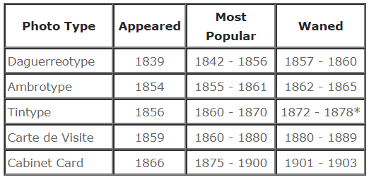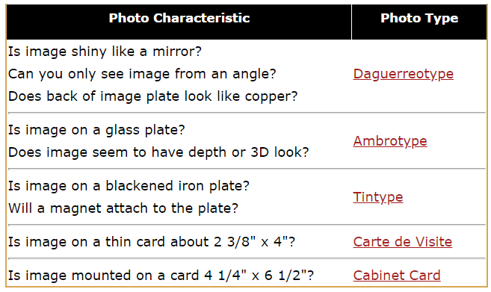 Taken from Phototree.com

Websites to date photo type
Phototree.com
http://phototree.com/images/phototree_paper_photographs.pdf
Khan Academy https://www.khanacademy.org
RPPC
Dating postcards http://www.thewebfooters.com/html/postcard_dating.html
Stamp Box on postcards https://www.playle.com/realphoto/
Websites to date pictures
University of Vermont: http://www.uvm.edu/landscape/dating/index.php http://www.photosmadeperfect.com/Photo%20Dating%20Page%20Top%20pg/AA%20Mens%20Fashions%20By%20Decade.htm
Fashion Era
https://www.fashion-era.com/
https://www.fashion-era.com/Dating_Costume_History_Pictures/1913_mourning_photos.htm

Collector’s Weekly https://www.collectorsweekly.com/photographs/tintypes

https://www.photographymuseum.com/

https://www.familysearch.org/blog/en/3-tips-identifying-family-photos/
https://www.archives.gov/files/education/lessons/worksheets/photo_analysis_worksheet_former.pdf
Internet Genealgy Magazine: https://www.internet-genealogy.com/lectures.htm
https://www.archives.gov/education/lessons/worksheets
http://www.loc.gov/rr/print/resource/Reading_Researching_Photographs.pdf
Ancestral findgins.com https://ancestralfindings.com/3-photo-identification-tips-you-never-knew-2/
Photographers
https://www.langdonroad.com/bak-to-bal not all inclusive 1844 -1950

https://photographymuseum.com/miphs.org/miphsTinderDirectory.html
Reverse Image search engines
Google Images. Google images is a widely used website to search images. ...
TinEye. TinEye is a product of Idee Inc., a Toronto based company. ...
Bing Image Match. ...Microsoft web search engine

Book Resources
Books available at Yavapai County Library District

Uncovering your ancestry through family photographs by Taylor, Maureen Alice.
Through the eyes of your ancestors : a step-by-step guide to uncovering your family's history by Taylor, Maureen
Dating old photographs, 1840-1929. Publication Information: Toronto, Ont. ; Lewiston, N.Y. : Family Chronicle, 2000.
Family photo detective: learn how to find genealogy clues in old photos and solve family photo mysteries Author: Taylor, Maureen Alice. Sharlot Hall Museum Library & Archives is not a lending library. You cannot check out books from SHM Archives

Want help dating a photo
Submit a photo (up to 1920, include size) to Raylene Hiatt at
rjunkins@cableone.net
by December 1 and we will help you at our NAGS Christmas meeting December 8th. Photos will be projected on the screen so everyone can see the photo and we can learn together. Send your photos and bring your cookies to the December meeting.

