MORE DATING PHOTOGRAPHS
Cyndi’s List https://www.cyndislist.com/us/

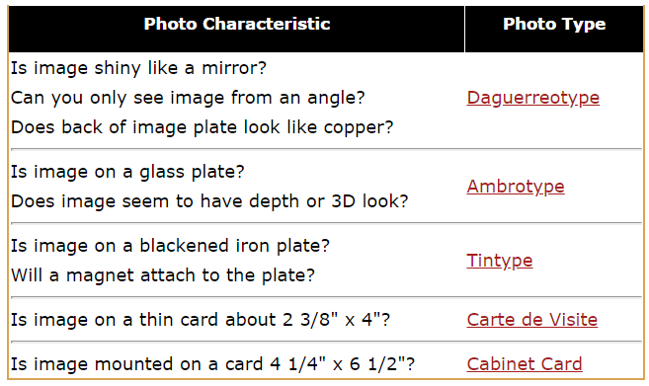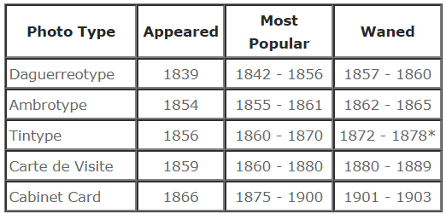
Taken from Phototree.com

Photographers of Great Britain and Ireland
http://www.cartedevisite.co.uk/dating/types-of-photograph/carte-de-visite/

Photographers
https://www.langdonroad.com/photographers-c
Google.com for state photographers also Name of company
https://books.google.com/ for state photographers also Name of company
Family History Books https://books.familysearch.org/ for state photographers also Name of company
https://www.cyndislist.com/photos/ as well as state you are searching.
http://genealogytrails.com/search.html
check Facebook

Hats
https://ahundredyearsago.com/2014/04/10/1914-easter-hats/

Childrens Clothes
https://www.historyonthenet.com/authentichistory/1898-1913/3-consume-leisure/6-Consumerism/1914_Sears_Housewares/index.html
http://www.phototree.com/gallery.asp?cat=hat&f0=hat

Mustache
http://www.phototree.com/gallery.asp?cat=mustache&f0=Mustaches

Interesting tidbits
No Other Time In History is a list of clothing items or fashion fads, that are seen "only in" a or "only after" a specific time. So if you have photographs with any of these items it will help you narrow down or dismiss any decade you had in mind or you can research the item further.
After 1840, pants with drop front button flaps are never seen again with the exception of sailors.
After 1840 lapels on men's jackets with the "M" notch are rarely seen.
After 1850 pagoda sleeves were out of fashion.
After 1860 Round floor length hoop skirts were out of fashion.
After 1865 (Civil War) and not so much after the late 1880's, veterans and freed slaves headed West looking for work and found it driving cattle, they became the first American cowboys. They work bandana's for the dust, leather chaps on their legs, dungarees and cowboy hats.
In May 20, 1873 Levi Strauss patented blue jeans, (denim, dungarees) mostly worn by gold miners, farmers and cowboys.
After 1913 President Theodore Roosevelt, an avowed Audubon Society sympathizer, and a widespread letter-writing campaign driven by church associations, many of whom distributed the Audubon message in their various newsletters, the plume trade was halted by such laws as the New York State Audubon Plumage Law (May 1910), which banned the sales of plumes of all native birds in the state. By 1920, similar laws were enacted in about 12 other states. Audubon Society activities are responsible for many laws for the establishment of game commissions and game warden forces, or prohibiting the sale of game. In conclusion between the periods of 1910 and 1920 the use of birds in ladies fashion that date it was likely a re-worked updated hat.
After 1918 (WWI) names of ships on sailor hats were no longer used. They switched to just "US NAVY"
After 1918 (WWI) beards became unpopular due to health/sanitary concerns in the trenches with lice.
After 1933 cars lost that square look early cars had.
Taken from http://www.photosmadeperfect.com/Genealogy_%20Corner/Photo%20Dating%20Page%20Top%20pg/AAPhoto%20Dating%20Fashion%20History.htm#Opening%20Comments

https://www.historyonthenet.com/authentichistory/1898-1913/3-consume-leisure/6-Consumerism/1914_Sears_Housewares/index.html

http://www.photosmadeperfect.com/Genealogy_%20Corner/Photo%20Dating%20Page%20Top%20pg/AAPhoto%20Dating%20Fashion%20History.htm#Samples%20of%20photographs%20by%20decade
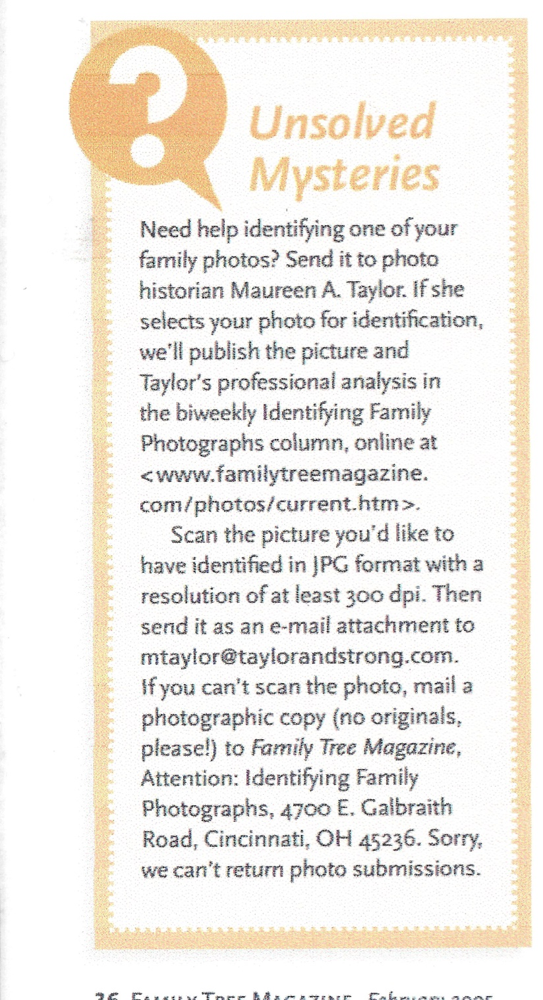
D Sue Kissel dskissel@cableone.net

